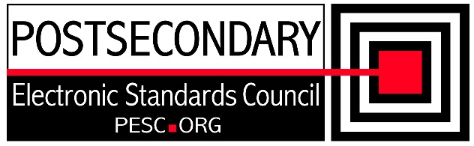

**Standards Forum for Education**

**Status Update Form**

|  |  |
| --- | --- |
| **Workgroup/Board Group Name** | Technical Advisory Board/JSON Task Force |
| **General Summary of Status** | Discussing role of JSON-LD and SHACL use by PESC |
| **Status Flag** (Green) | Green |
| **Report Data** | 05/12/2023 |
| **Projected Completion Date** | Standing PESC Board |

|  |  |  |
| --- | --- | --- |
| **Item** | **Responsible Resource** | **Status**  (Report update status of Deliverable/Objective  since last report) |
| **Planned Deliverables/Objectives**  (Provide at least 3) |  |  |
| JSON-LD | JSON-LD Task Force | Discussed Credential Engine JSON_LD context and Schema. |
| SHACL Implementation | JSON-LD Task Force | Python prototype available for constraint testing of JSON_LD by SHACL |
| Schema Changes | TAB/CCB | None |
| **Accomplishments/**  **Completions** |  | None |
| **Issues/Obstacles** |  | None |
| **Meetings/Calls Since Last Update** | 4 | (includes JSON-LD task force and TAB/CCB) |

***Note***: Chairs and/or leaders of workgroups, boards and committees under The Standards Forum for Education are required to provide updates during the Steering Committee’s monthly conference call meeting held the second Friday each month at 2:00pm EST. Call in information is: **866-352-3799 *7696363\***. Forms must be completed and submitted prior to meeting time. Forms may also be posted on the PESC website as needed to provide the community at-large with a means to obtain updates for ongoing, but yet to-be-completed development efforts.

|  |
| --- |
| To add rows to table, click outside of the table, to the right on the row where you want to add another row . With cursor blinking, hit the enter key. A new row will be inserted. |